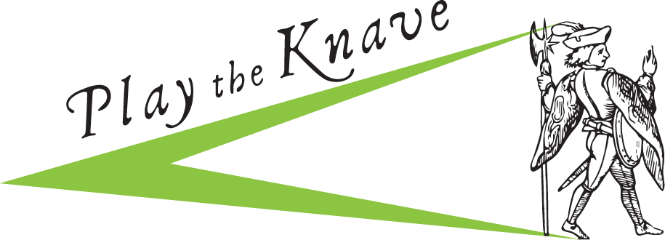

Are you thinking about a career in teaching?

Do you love Shakespeare?

Apply for the English Department’s
Play the Knave
Teaching Internship Program

***Apply online by Sunday, October 22***
Direct link to application: https://goo.gl/forms/258p8R46VkPJdmFQ2

Questions?
Gina Bloom (project director) at gbloom@ucdavis.edu
Amanda Shores (head teaching intern) at alshores@ucdavis.edu

Frequently Asked Questions

What is Play the Knave? An augmented reality video game/digital tool that was developed by English professor Gina Bloom and members of the UC Davis ModLab. Players stage scenes from Shakespearean drama, karaoke-style. The game has been installed at theaters, libraries, and cultural institutions across North America and has been used in California classrooms (K-12 and college). Learn more at http://playtheknave.org/ and/or see coverage at BBC News.

What is the aim of this internship program? To provide a structured way for students who are considering careers in teaching to get some hands-on pedagogical training and experience. Although our focus will be Shakespeare, theatrical performance, and technology, the internship will be useful to students regardless of the subject areas or grade level they wish to teach. It will also be of use to students who are not yet sure if they want a career in teaching as well as for students considering careers working with children or youths in other capacities.

What are the expectations for the internship? How will it work? Interns will be expected to devote a minimum of 2 hours per week to the program during Fall and Winter quarters, when they will be trained on teaching with Play the Knave. In the Spring quarter, all interns will sign up for a 3-unit English department class taught by Professor Bloom. (Course time TBD based on intern schedules.) As part of the course, students will collaborate with teachers in local schools to develop and execute lesson plans using Play the Knave.

Am I eligible? Any student is eligible for the program, though English majors and minors will have priority. Graduate students are also welcome. Prior Play the Knave interns are also eligible.

What kind of credit will I get? Although the internship offers no financial compensation, you can receive credit units (1-4 units of ENL 92 or 192 in the Fall and/or Winter; normal course credit in spring for the class you’ll take). You can also receive Transcript Notation in Fall and/or Winter, provided you work a total of 40 hours over the course the quarter in question. Additionally, Prof. Bloom will be in a good position to provide you with an employment reference for the future.

I need classroom experience so that I can apply for a teacher credentialing program. Will this internship count? Any time you spend in a public school classroom with students counts toward this requirement. But note that some of your internship hours will be spent outside of the classroom and thus would not count toward your “classroom experience” requirement for applications.

I am not very tech-savvy. Will that be a problem? Not at all! You’ll become tech-savvier by the end of the internship.

Do I have to be involved all three quarters? Yes, you do. However, the number of hours you commit during Fall and Winter can vary, provided you meet the 2-hour weekly minimum.

How flexible are the hours? During Fall and Winter quarters, your hours will be very flexible. During Spring quarter, your particular hours will depend on your arrangement with the local teacher with whom you are collaborating. You will also need to attend all sessions of the English department course associated with this internship (course time determined in consultation with all interns).

